PROJECT DEVELOPMENT PHASE DELIVERY OF SPRINT-1

|  |  |
| --- | --- |
| DATE | 25 OCTOBER 2022 |
| TEAM ID | PNT2022TMID51031 |
| PROJECT TITLE | GLOBAL SALES DATA ANALYTICS |

SPRINT 1:

* Registration to Cognos Analytics
* Understand the Dataset

REGISTER FOR COGNOS ANALYTICS

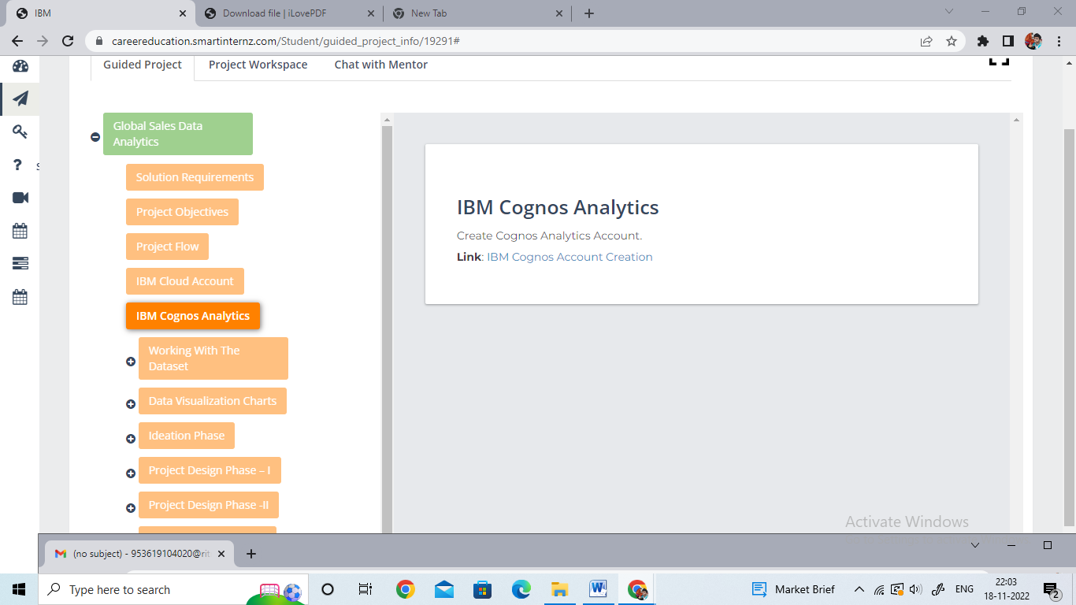

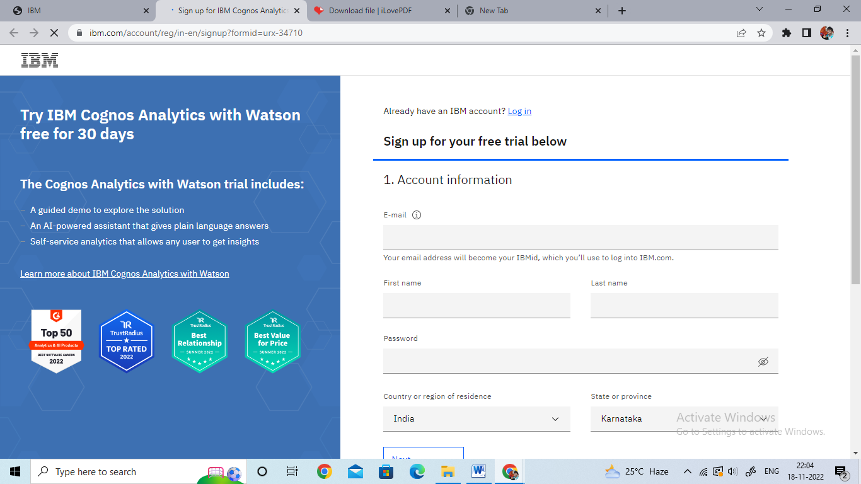

LOGIN TO COGNOS ANALYTICS WEBSITE

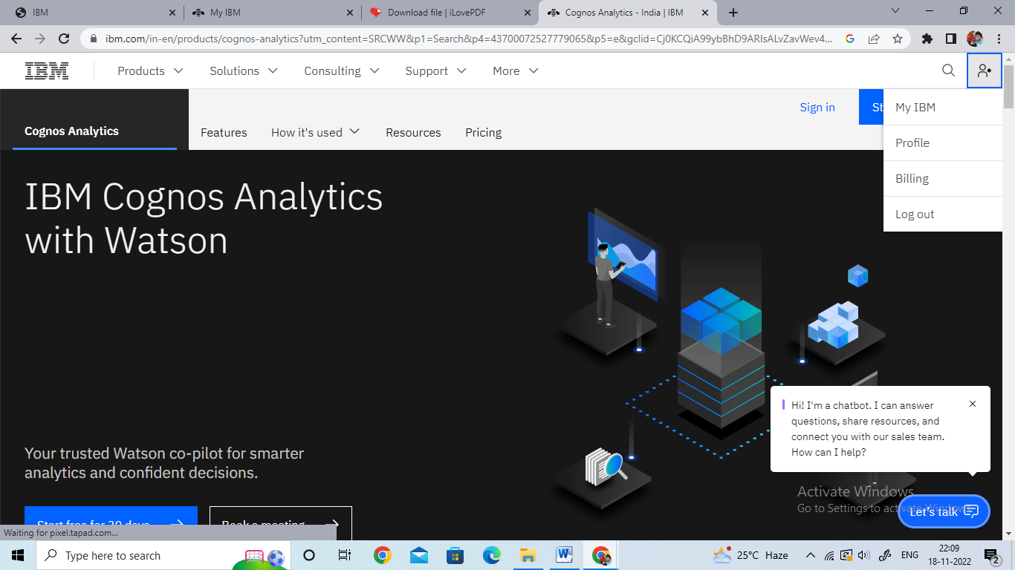

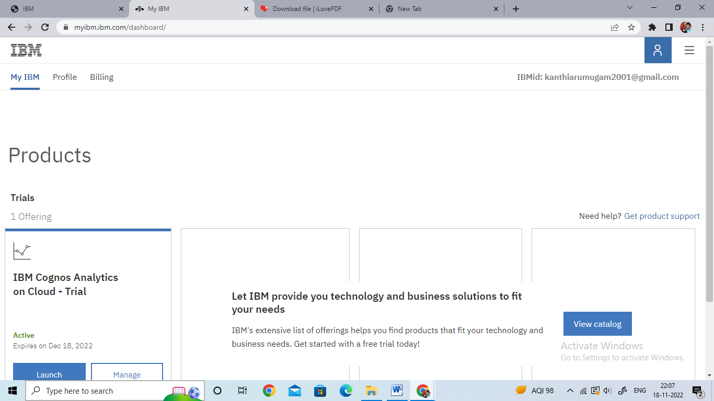

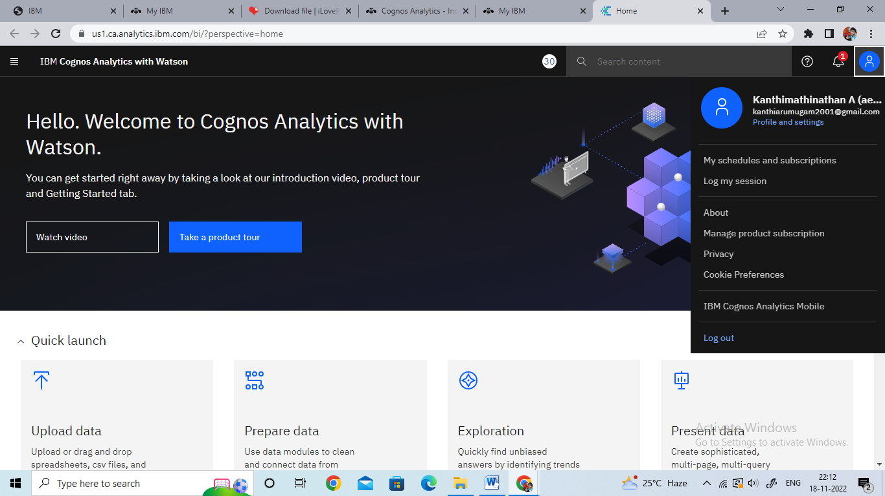

DOWNLOAD THE DATASET FROM KAGGLE

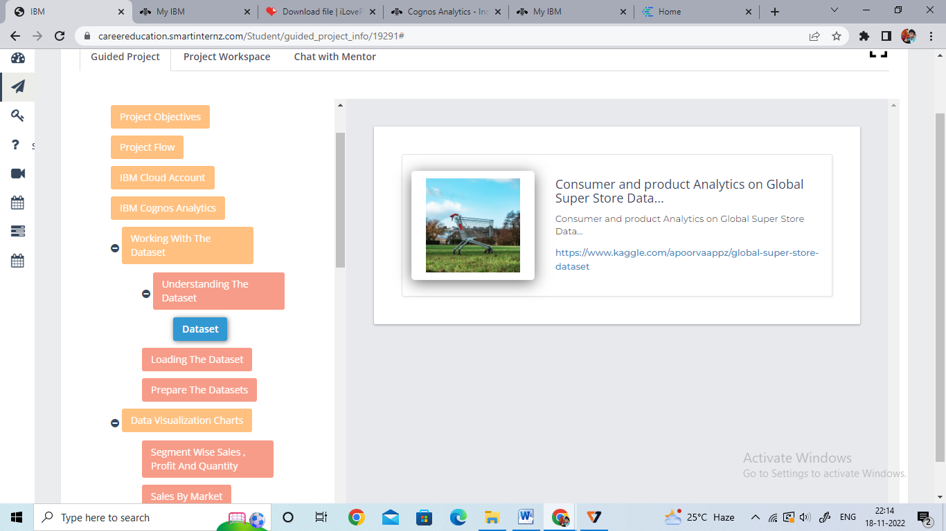

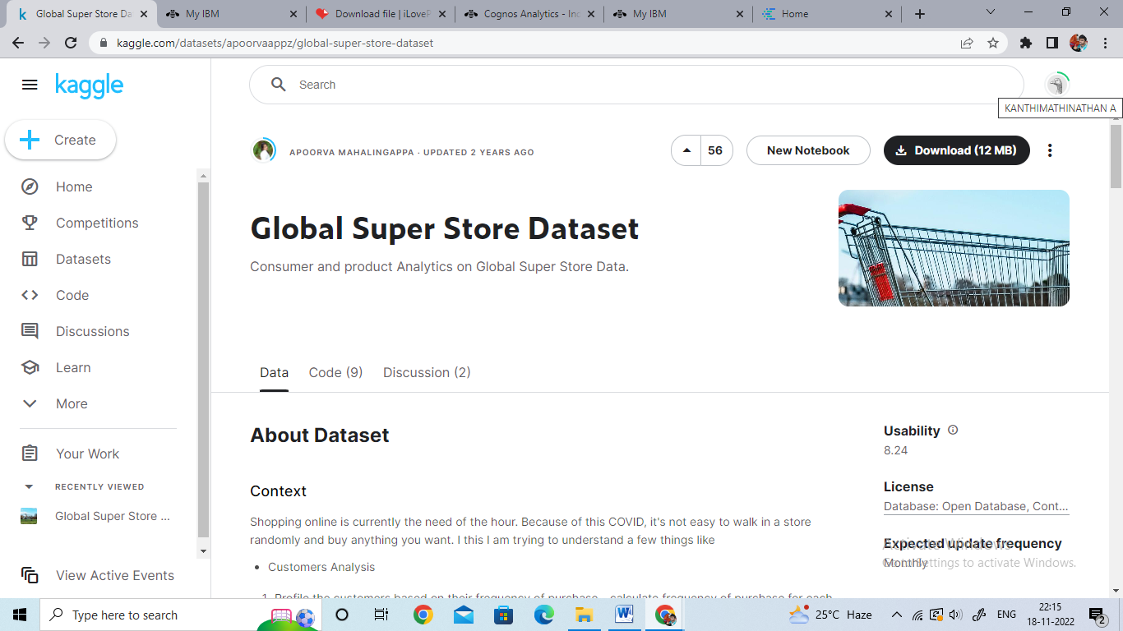

UNDERSTAND THE DATASET OF GLOBAL SUPERSTORE

